Lab Manual # 8
Objectives:
- To learn the implementation of Boolean function using multiplexer
- To learn how to implement Multiplexers using decoders
2-to-4 line decoders:
74LS139 IC contains two fully independent 2-to-4 line decoders with active low enables. The function table and connection diagram for this IC are shown below:
Function Table:
Enable | Selection Inputs |  | Outputs
G | B | A | Y0 | Y1 | Y2 | Y3
H | X | X | H | H | H | H
L | L | L | L | H | H | H
L | L | H | H | L | H | H
L | H | L | H | H | L | H
L | H | H | H | H | H | L

H= Logic High, L= Logic Low, X= Don’t Care

Connection Diagram:

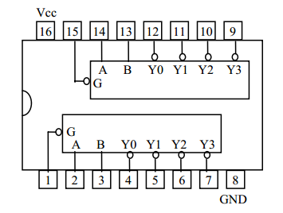

3-to-8 line decoders:
74LS138 IC contains 3-to-8 line decoder. The function table and connection diagram for this IC are shown below:
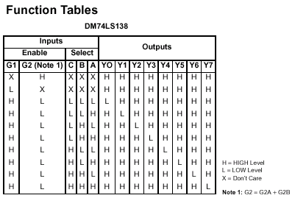
Connection Diagram:

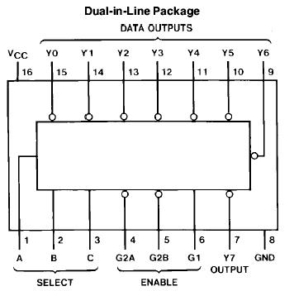
2x1 MUX:
74LS157 IC is a dual 4x1 MUX with active low enable.
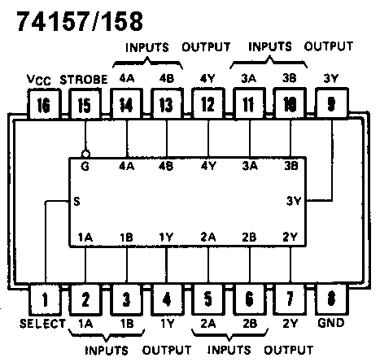
4x1 MUX:
74LS153 IC is a dual 4x1 MUX with active low enables. Two 4x1 MUXs with common selection pins but independent inputs and independent outputs is known as dual 4x1 MUX. The function table and connection diagram for this IC are shown below:

Function Table:

Strobe (Enable) | Selection Inputs |  | Data Inputs |  |  |  | Output
G | B | A | C0 | C1 | C2 | C3 | Y
H | X | X | X | X | X | X | L
L | L | L | L | X | X | X | L
L | L | L | H | X | X | X | H
L | L | H | X | L | X | X | L
L | L | H | X | H | X | X | H
L | H | L | X | X | L | X | L
L | H | L | X | X | H | X | H
L | H | H | X | X | X | L | L
L | H | H | X | X | X | H | H

H= Logic High, L= Logic Low, X= Don’t Care

Connection Diagram:

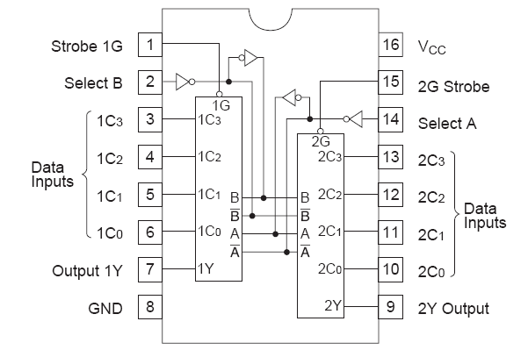

LAB TASKS
Question 1:
Implement 4x1 mux using one 2x4 decoder, four ANDs and three OR gate.

Question 2:
Implement the following function using 4x1 mux
F (X, Y, Z) = m1 + m2 + m6 + m7
Question 3:
Design a circuit that takes two 2–bit numbers and outputs their product.

POST LAB
Question 4:
Implement 4x1 MUX using two 2x1 MUXs only.

